### How to Make a Miniature Math Book

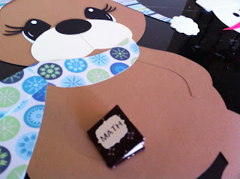

Miniature Math Book

I started the day by making a bulletin board for my math class. I bought the design from the Silhouette store. I think the snow bunny by Stinkin Cute is exactly what the name says... stinkin cute!

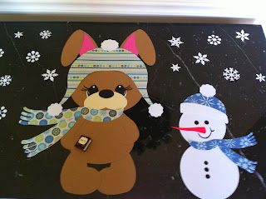

Here are the figures that I enlarged for the bulletin board.

I needed a theme for the bulletin board and I came up with the following title..."Every Bunny Loves Math". I wanted to put something in her hand and I decided to use a math book. I had a miniature math book that I made from a few years ago. I attached it to the bunny and thought...Eureka...why not do this project again with my students.

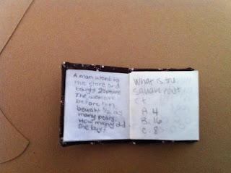

Here is a page from this book.

Making a miniature math book is a fun project for math students. It gives them the opportunity to be creative and to make up their own math problems. In addition, you can have them make up an answer key on a separate sheet of paper. The books can then be passed around to other students who have to solve the problems on a separate sheet of paper. The author of the math book could then correct the answers to their book. It can also be adapted for older students. For example, students can outline a chapter in their math book. It could include definitions and sample problems as a chapter review.  
This project should be done over the course of a few days. Ideally, it can be done in the last ten or fifteen minutes of the class when classwork is completed. Students will have everything they need already cut out...thanks to the Cameo Silhouette. They will take the fabric as shown with the printed side down and they will glue the cardstock as shown...centering it in the fabric with a quarter inch separating the cardstock, in the middle, for the spine of the book. (I would place the cardstock in the correct position as you hand it out to the students.

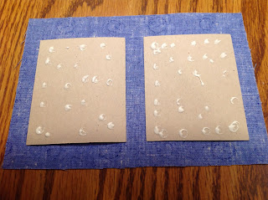

Put glue on the cardstock and flip it over when done.

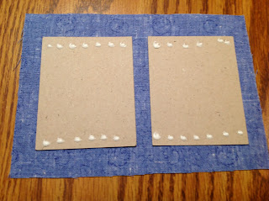

Put glue on the cardstock as shown.

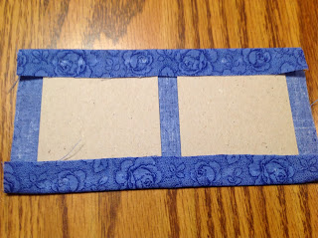

Fold over the top and bottom fabric.

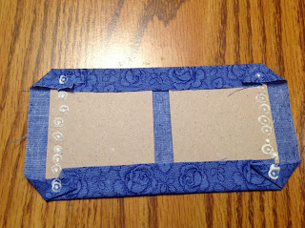

Put dots of glue in the four corners by the cardstock on the fabric and then

origami fold the corners into a triangle. Apply glue to the outer edge of the cardstock.

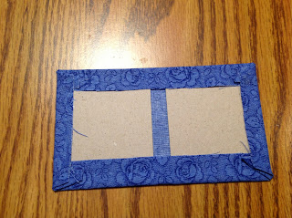

Fold the remaining fabric over the cardstock. It should now look like the above picture.

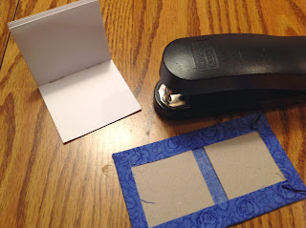

Staple the pages together in the middle crease in two places as shown. (You could do this before class to eliminate this step.)

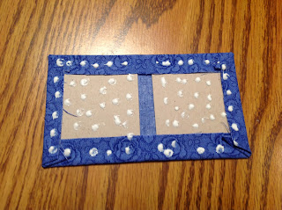

Put glue on the entire cover except in the middle where the spine will be.

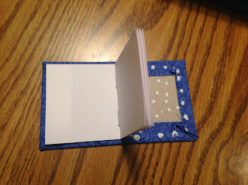

First, attach the pages to the one side.

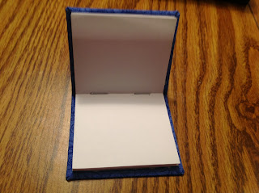

And then to the other side.

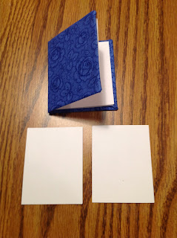

Design a front and back cover. Glue when completed.